

Draw It or Lose It – Web-Based Game Application

CS 230 Project Software Design Proposal
Version 2.0

Table of Contents

CS 230 Project Software Design Template 1
Table of Contents 2
Document Revision History 2
Executive Summary 3
Requirements 3
Design Constraints 3
System Architecture View 3
Domain Model 3
Evaluation 4
Recommendations 5

Document Revision History

Version | Date | Author | Comments
1.0 | 06/25/26 | Nikita Simon | Initial software design document for The Gaming Room application.

Executive Summary

The Gaming Room intends to expand its Android-based game, Draw It or Lose It, into a web-based application capable of supporting multiple operating systems and devices through a single software solution. The new application must maintain consistent gameplay across platforms while making sure that game, team, and player names remain unique and that only one instance of the game service exists in memory at any given time.

This design proposes a Java-based distributed application that employs established object-oriented design patterns to improve maintainability, scalability, and reliability. By implementing the renowned Singleton pattern for the game service and the Iterator pattern for searching existing game objects, the proposed architecture satisfies the client's functional requirements while providing a flexible foundation for future expansion.

Requirements

Business Requirements

- Expand Draw It or Lose It beyond Android to a web-based application.
- Support users on multiple operating systems and devices.
- Maintain consistent, undisturbed gameplay regardless of platform.
- Ensure every game, team, and player has a unique name.
- Allow multiple games to operate simultaneously.

Technical Requirements

- Develop the application using Java.
- Implement the Singleton design pattern to establish a single GameService instance.
- Use the Iterator pattern when browsing collections of games, teams, and players.
- Assign unique identifiers to every game, team, and player.
- Design the application using object-oriented principles for future scalability and maintenance.

Design Constraints

The application must ideally operate as a distributed web-based system capable of supporting clients on Windows, macOS, Linux, and mobile devices without requiring platform-specific implementations. Consequently, the software should rely on Java's platform independence and avoid dependencies on operating-system-specific functionality.

The client requires that every game, team, and player possesses a unique identifier and name. This constraint necessitates implementing validation logic before new objects are created and maintaining centralized and stern control of identifier generation through a singleton service. Without these safeguards, duplicate objects could compromise application integrity.

The software must also remain scalable and maintainable as upcoming features are introduced. To satisfy this requirement, the application should follow object-oriented principles including inheritance, encapsulation, and abstraction while employing recognised software design patterns such as Singleton and Iterator. These patterns reduce code duplication, introduce predictability, simplify maintenance, and improve long-term extensibility.

System Architecture View

Please note: There is nothing required here for these projects, but this section serves as a reminder that describing the system and subsystem architecture present in the application, including physical components or tiers, may be required for other projects. A logical topology of the communication and storage aspects is also necessary to understand the overall architecture and should be provided.

Domain Model

The UML class diagram showcases the domain model for the Draw It or Lose It application by defining the primary entities involved in gameplay and the relationships between them. At the centre of the design is the Entity base class, which encapsulates the common attributes shared by all game objects, namely a unique identifier (id) and a unique name (name). Rather than duplicating these properties across multiple classes, the Game, Team, and Player classes inherit from Entity, promoting code reuse and simplifying future maintenance.

The GameService class functions as the central controller responsible for creating, storing, and managing game instances. It applies the Singleton design pattern to ensure that only one instance of the service exists throughout the application's lifetime, allowing identifiers to be generated consistently and preventing duplicate or simultaneous game service objects. GameService maintains a collection of Game objects, while each Game contains zero or more Team objects, and each Team contains zero or more Player objects. This hierarchical relationship accurately models the real-world structure of the game, where a single game may consist of multiple teams and each team may contain multiple players.

Several object-oriented programming principles are depicted realistically throughout the design. Inheritance is achieved through the Entity base class, allowing common attributes and behaviours to be shared among Game, Team, and Player. Encapsulation is painstakingly maintained by keeping object data private while exposing controlled access through constructors and accessor methods. Abstraction simplifies the overall design by separating shared functionality from specialised behaviour, enabling each class to focus on its individual responsibility. The design also incorporates recognised software design patterns. The Singleton pattern guarantees a single GameService instance, while the Iterator pattern is used when searching collections to ensure that game, team, and player names remain unique before new objects are created. Together, these principles and patterns produce a scalable, maintainable, and efficient architecture that satisfies the client's requirement for a distributed, multi-platform game application.
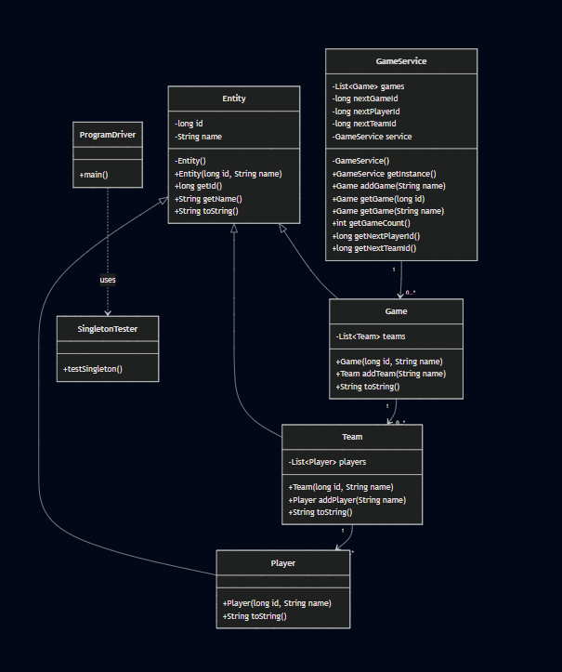



Evaluation (next page)

Evalution | Mac | Linux | Windows | Mobile Devices
Server-Side Requirements | macOS offers server capabilities, though it is not commonly selected for enterprise web hosting. Apple's hardware restrictions and limited server ecosystem make it less practical for large-scale deployment. Whilst macOS provides excellent stability and security, it is generally better suited for software development than production server environments. | Linux is the preferred operating system for hosting modern web applications because it provides exceptional stability, reliability, security, and scalability. Most cloud providers and enterprise data centres rely on Linux due to its open-source nature, minimal licensing costs, and strong support for Java web applications, Apache, Nginx, and container technologies such as Docker and Kubernetes. | Windows Server provides a mature environment for hosting web applications and supports a broad range of enterprise software. Its graphical administration tools make server management accessible, although licensing costs can become expensive as deployment scales. Windows is suitable for organisations already invested in Microsoft's ecosystem but may not provide the same cost-effectiveness as Linux for large-scale cloud hosting. | Mobile operating systems are not designed to host web servers for enterprise applications. Instead, Android and iOS function exclusively as client platforms that communicate with the server through secure RESTful APIs over HTTPS.
Client-Side Requirements | Safari serves as the primary browser on macOS whilst remaining fully compatible with modern web technologies. Responsive interfaces and cross-browser testing ensure consistent experience alongside Windows and Linux users. | Linux users have access to browsers such as Firefox and Chrome that fully support HTML5, CSS3, and JavaScript. Standards-based web development ensures compatibility without requiring operating-system-specific modifications. | Modern browsers such as Microsoft Edge, Google Chrome, Mozilla Firefox, and Opera provide exceptional compatibility for responsive HTML5 web applications. Development should follow recognised web standards to ensure consistent experience across browsers. | Responsive web technologies allow Android and iOS devices to access the application through their browsers without requiring separate native applications. This approach largely reduces development costs whilst maintaining consistent functionality across smartphones and tablets.
Development Tools | macOS supports the same Java development ecosystem whilst additionally offering Xcode for Apple-specific development. Developers targeting Apple devices may require access to macOS hardware and an Apple Developer account. | Linux supports nearly all modern open-source development tools, including Eclipse, IntelliJ IDEA, VS Code, Git, Maven, Gradle, Docker, and Kubernetes. Most tools are freely available, making Linux highly attractive for development teams seeking to minimise licensing costs. | Windows supports a wide selection of development tools, including Eclipse, IntelliJ IDEA, Visual Studio Code, Git, Maven, and Java Development Kit (JDK). Some commercial tools require licensing, whilst many open-source alternatives remain freely available. | Mobile platforms require responsive web design frameworks, browser testing tools, and device emulators to ensure compatibility across different screen sizes and operating system versions. Supporting multiple platforms increases testing requirements but avoids maintaining separate native codebases when using browser-based deployment.

Recommendations

After evaluating each operating platform, Linux is the strongest recommendation for hosting The Gaming Room's Draw It or Lose It application. Linux provides outstanding scalability, reliability, security, and cost-effectiveness whilst eliminating expensive server licensing fees. Its widespread adoption within cloud computing environments also makes it an ideal foundation for supporting thousands of concurrent users as the application continues to expand. The extensive availability of enterprise web servers, Java runtime environments, container technologies, and cloud deployment tools further strengthens Linux as the preferred server platform.

For the client side, adopting a responsive browser-based application built with HTML5, CSS3, and JavaScript offers the greatest flexibility. This solution enables Windows, macOS, Linux, Android, and iOS users to access the same application through modern web browsers without requiring separate platform-specific implementations. Maintaining a single codebase substantially reduces long-term development effort, simplifies maintenance, and ensures new features are delivered consistently across all supported devices.

The development team should continue using Java as the primary programming language alongside Eclipse or IntelliJ IDEA, Maven for dependency management, Git for version control, and RESTful APIs for communication between the client and server. As the application evolves, incorporating container technologies such as Docker and orchestration platforms such as Kubernetes will further improve scalability, deployment consistency, and operational resilience.

From a security perspective, the application should employ HTTPS encryption, role-based authorisation, secure password hashing, regular dependency updates, comprehensive input validation, and routine security audits. These measures will help safeguard user data whilst ensuring the application remains resilient against evolving cybersecurity threats.

Lastly, Linux provides the most suitable server environment, whilst a responsive web-based client architecture delivers the broadest platform compatibility at the lowest long-term maintenance cost. This combination aligns closely with The Gaming Room's objective of expanding Draw It or Lose It into a secure, scalable, and maintainable multi-platform application capable of supporting future growth.

